**Praveen Kumar S** 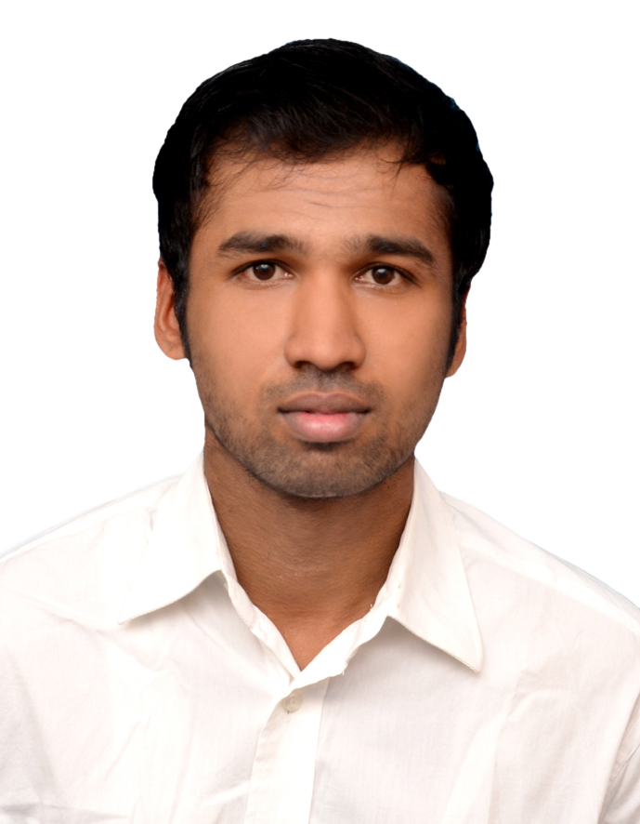

**E-MAIL :praveensharp005@gmail.com**

**CONTACT :8870448503**

**CAREER OBJECTIVE:**

**To be a part of an organization where I could use and enhance my knowledge and talent for the development of both organization and myself.**

**ACADEMIC PROFILE:**

|  |  |  |  |  |
| --- | --- | --- | --- | --- |
| **COURSE** | **NAME OF THE INSTITUTION** | **BOARD / UNIVERSITY** | **YEAR OF COMPLETION** | **PERCENTAGE**  **SECURED** |
| **BSC**  **(Computer science)** | **PSG College Of Arts and Science** | **Bharathiyar University** | **2017** | **5.6\*** |
| **HSC** | **Literacy Mission Matric**  **Higher Secondary School** | **Matriculation** | **2014** | **82.8%** |
| **SSLC** | **Literacy Mission Matric**  **Higher Secondary School** | **State Board** | **2012** | **85.5%** |

**AREA OF INTEREST:**

* **Web Developement (User Interface)**

**KEY SKILLS:**

* **Ability to work as team or individual**
* **Good in communication skill**
* **Computer savvy**
* **Target Oriented**

**HOBBIES:**

* **Playing Cricket**
* **Daily News**
* **Care Taking My Dogs**

**TECHNICAL KNOWLEDGE:**

* **Responsive Design**
* **SVG**
* **Media Queries in CSS**
* **Basic JavaScript**
* **Bootstrap 4**

**EXTRA-CURRICULAR ACTIVITIES:**

* **District Level Handball**
* **Typing Skill**

**CERTIFICATION:**

* **HTML (!DOCTYPE HTML)**
* **CSS (Cascading Style Sheet)**
* **Java Script**

**PERSONAL DETAILS:**

* **Father Name : Selvaraj R**
* **Mother Name : Poongodi S**
* **Date of Birth : 03-06-1996**
* **Language Known : Tamil & English**
* **Gender : Male**
* **Place : Tiruppur**
* **Pin code : 641668**
* **Nationality : Indian**

**DECLARATION:**

**I here by declared that the above given informations are true to my knowledge.**

**Yours faithfully**

**Signature**